Nina Cristante
fitness povero – homeworks

21th August 2015 > online project @ 63rd-77th STEPS - Art Project Staircase

fe adrab bas not bad ma mbayan ino muscles like fats. for moms and peeps that can't make it to the gym, fitness povero promotes self sufficient and cost efficient lifestyles in time of austere tightness and active living. livesore. x9 total body workouts, x1 full body stretch. music by Nina Cristante (https://soundcloud.com/ninandkris).

63rd-77th STEPS presents “fitness povero-homeworks”, an online project by Nina Cristante, on view from 21 August 2015 on our website, consisting of a new series of home-workouts and full body stretch with accompanying piano exercise music.

Nina Cristante lives and works in London. Her main project, Zao Dha Diet has different declinations, from health consultations to fitness povero workouts to exercise music.
Generally, her work deals with health and wellbeing.

>> http://zdd.website/ <<<

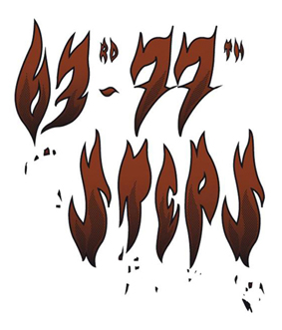

63rd-77th STEPS - Art Project Staircase - is a project space for contemporary art founded and run by the artist Fabio Santacroce. The name refers to the final part of a multi-floor staircase
(the area between the 63rd and the 77th step) inside a building from the
beginning of the XX century in Bari (Italy).

www.63rd77thsteps.com
www.facebook.com/63rd77thSTEPS
https://twitter.com/ArtStaircase
http://instagram.com/63rd77thsteps/

